Sharjah Roads and Transport Authority
Name
Institution Affiliation
Date

Table of Contents
Introduction: 3
Problem description: 4
Problem boundaries and impacts: 6
Solution criteria and limitations: 7
Time-based plan for researching problem solutions: 8
Reference 10

List of Figures
Figure 1: Organization structure of SRTA 4
Figure 2: Number of vehicles recorded at a given time. 5
Figure 3: Road and Lighting System 6

List of figures
Table 1b: Time per Branch (In Seconds) 7
Table 2: Street Lighting Without sensor 8
Table 3: Specifications of the problem 8
Table 4: Description of the solution 9
Table 5Time-based plan for researching problem solutions: 9
Table 6 Gantt chart 10

Introduction
Sharjah Roads and Transport Authority located in located in Al Aezzrh area with other branches in Kalba and Khorfkan has responsibilities of planning as well as ensuring a smooth implementation of roads and transport projects in the City. The Authority also has responsibilities of preparing strategic plans and legislation. In addition to these the authority also comes up with the integrated solution to road and marine network systems that is of international standard and ensure that they are safe and according to the various laid down economic development of the country. Every road project in the SPTA system must be environmental friendly and provide a favorable for people (PTV AG, 2007).
Until today SPRTA has successfully implemented many project in Sharjah City which is in accordance with its objectives to provide solution to many problems in the city. With statistics indicating that about 15% of employees get late to their places of work as a result of the unending traffic jams in the city as well as excessive wastage of fuels in the jams and pollution of the environment.
Due to these traffic jam related problems and the increasing number of vehicles in the United Arab Emirates and the high rate of growth of population in Sharjah town, there was need to come up with traffic management system during the rush hours to ensure smooth flow of vehicles in the town center and to encourage many people to use public vehicles in the city (PTV AG, 2007).
Mr. Mohammed Iqbal therefore so the need to come up with traffic light that gives signals to the drivers together with the pedestrians on the use of these busy roads and to reduce the level of deaths related to the traffic jams (Sharjah overhauls transport services, 2015). This system’s main objective was to design an attractive and modern that ensures smooth flow of the traffic that encourages people to use road transport. In achieving these objectives the following hierarchy has to be followed for a successful implementation of the traffic light system (PTV AG, 2007).
Figure 1: Organization structure of SRTA
Director General and Chairman of the Board of Directors
Internal audit
Services of technical support of enterprises
Institutional Support Services
Railway Corporation
Traffic & Roads Est.
Transportation Foundation
Control Room
Sharjah Roads and Transport Authority
Engineer Mohammed Iqbal Mir

Problem description:
As a result of the increasing number of people in Sharjah accompanied by the increasing number of vehicles in the City there is need to use traffic lights to control traffic in the City as this has been seen to be successful in other parts such as in Dubai. The number of traffic in the city is also varying overtime with some hours of the day such as the rush hours witnessing high traffic (PTV AG, 2007). In Wasit Street near Al Qasimi Hospital where there is a fixed street light for example there are 3 peak hours that record high vehicle density 3 specific times of the day. These peak hours are the morning hours from around 6 AM to 9 AM, noon from 12-3PM and 5 to 8 PM as shown in table below. Similar case is therefore most likely to be witnessed in other roads too resulting to the need to come up with street lighting system that is time saving in all the roads in the City. The table.1a and fig.1b shows the number of vehicles on the road at a given time.

Figure 2: Number of vehicles recorded at a given time.

This flexible street lighting is centered on timed traffic lighting with two colors, Red and green. These lights are used alternatively in different sides of the road meaning the signal is red or green for a specified time for each side of street irrespective of vehicles. For example in table 1, fig.3, the 4 sides of the roads are timed at 40, 35, 55 and 45 seconds respectively. The 20 seconds gap is used for the first car to pass hence and therefore need to ensure accurate timing to avoid any collisions.

branch’s | The specified time
Branch 1 | 40 seconds
Branch 2 | 35 seconds
Branch 3 | 55 seconds
Branch 4 | 45 seconds

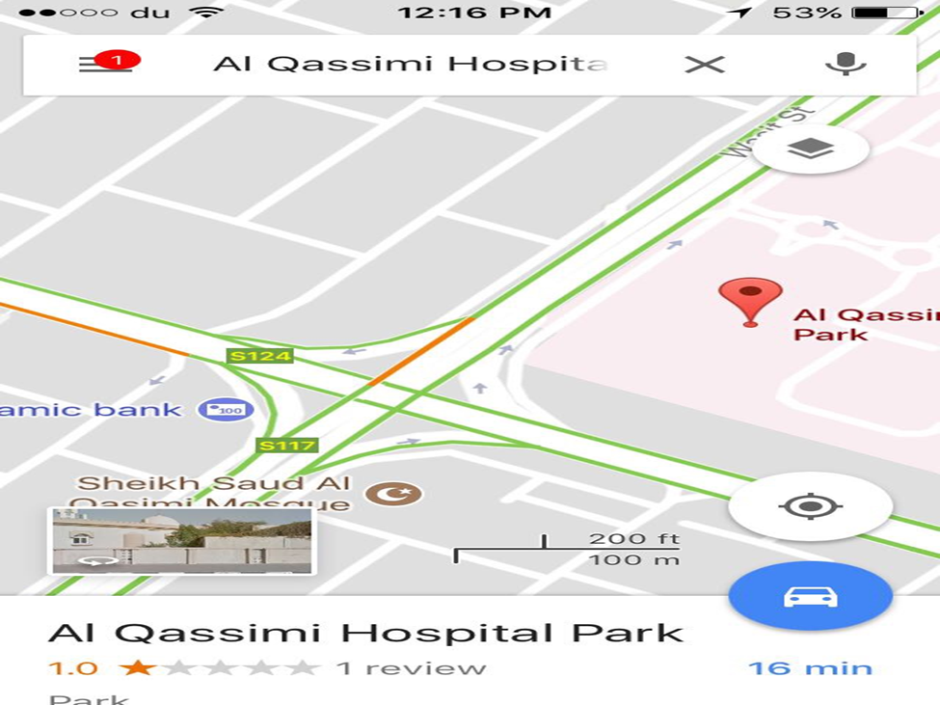

In a case where there are no vehicles in one side of the road and the others are crowded, there is need of intersection and therefore need for the dominant flows to be adapted to change overtime during the day. This different with the fixed lighting in other places where the driver has to wait for the time to elapse before intercepting. In this system when a vehicle hits the loop it is detected by the detector card which passes an information to the Central Processing Unit (CPU) which checks which among the vehicles comes first and gives an indication of a green light to the first vehicle to pass and a red for a 20 seconds stop of the other car until the first vehicle passes.

Problem boundaries and impacts:
The boundaries of the problem will be the traffic lights signals and the sensors. The impact will be the traffic havoc along Wassit Street and it may cause car accidents in the sounded areas.

Solution criteria and limitations:
To solve any problem, it must be taken in consideration all the limitations that may hinder the work later.
This part will discuss the specifications of the current method which is using traffic light signals without sensors, the specifications of the solution and the resources of the solution.
Table 2: Street Lighting Without sensor
Specifications of the current method | Description
Sensitivity | low
Reliability | low
Complexity | simple

The table below will illustrate the specifications and the resources of the solution
Table 3: Specifications of the problem
Specifications | Discerption
Cost | The maximum budget for SRTA to pay is 80,000 DHS.
Time of the problem table | SRTA wants the system to be developed by a period that does not exceed two months.
Sensitivity | Sensitivity will be high because the solution will have sensors.
Reliability | It will be very high to avoid any risk in the system.
Complexity | Based on the company demand the system must be easy to be installed.

Table 4: Description of the solution
Resources | Description
Equipment | Electronic labs, workshops, power supply, drill, Excavators, laptop.
Tools | Screw driver, spanners, players, cutters, bolts, pros kit tools bag, pipes.

In the implementation phase the problem require a specific criteria which is the help of police men and the municipality
Skills (Human Resources)
Activity | SRTA | Engineer  (instrumentation engineer) | Technician  (civil engineer ) | Electrician | labours | The team (Aysha ,Roqaya and Shaima)
Approve | R | S
Test |  | R | S | S |  | S
Install | R | S | S | S | S
` |  |  |  |  |  | R:responsible  S:support

Time-based plan for researching problem solutions:

The next step for the following report is to do research for problem solution. The project will take 5 weeks and 3 days to be completed; it will start from 25th September 2017 to 5th November 2017. Table (1) contains the activities with the specific period for each one to be as a plan for the next phase.

Table 5: Time-based plan for researching problem solutions:

ID | Brief description | Duration | predecessor | Name of student
A | Brainstorming to find ideas. | 1 | - | Aysha
B | Identify the proposed systems | 3 | A | Aysha
C | Literatures survey | 3 | B | Roqaya
D | Explanation of how solution work. | 3 | C | Shaima
E | Show the advantages and disadvantages of each solution. | 5 | D | Aysha
F | Discuss the idea of each solution and what it needs. | 6 | E | Shaima
G | Evaluate the data by using decision making techniques. | 7 | F | Roqaya
H | Select the best solution | 2 | G | Roqaya

Table (1)
The Gantt chart is a type of bar chart that illustrates a project schedule. Its shows the start and the finish dates of the project as shown in
Table 6 Gantt chart
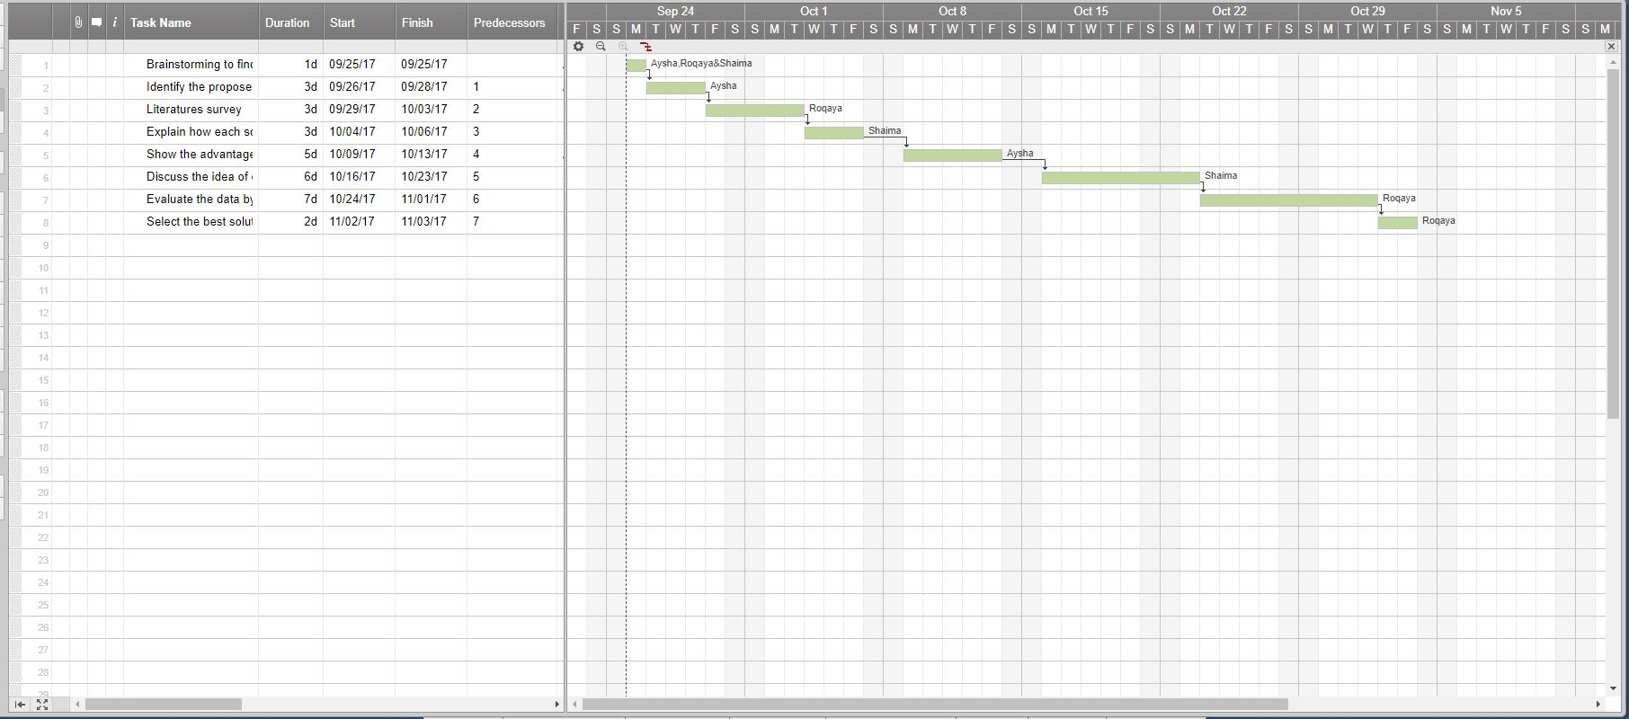

Reference
Sharjah overhauls transport services. (2015, September 29). (sharjahupdate) Retrieved from http://www.sharjahupdate.com/2015/09/sharjah-overhauls-transport-services/
PTV AG (2007). Sub-Report “Bus Network Planning”, Appendix C – Present Network Analysis. Dubai Public Transport Bus Master Plan.
Africon Ltd. Dubai (2006). Derivation of Updated 5-Year Transportation System Implementation Plans for Dubai, 14.

